MSI-RES(2022)05-01
16 June 2022

Good practices for sustainable news media financing
Outline for the report

Elda Brogi, European University Institute
Helle Sjøvaag, University of Stavanger

Aim of the report: The report collects good practices of media sustainability at national levels. Analysing some trends in Council of Europe Member States can help in forecasting the future scenarios and imagining media policies fit to ensure media sustainability and plurality in the changing media market landscape.

Introducing the topic

The sustainability of the media and the media markets is strictly connected to media pluralism (external pluralism) and, in the end, to democracy.

Recent years have witnessed a steady decline in the sustainability of traditional business models of many news organisations. There are many causes of this shift. The main one is technological development that has brought about a swift change in both consumer and advertiser behaviours.

More recently, this trend has been exacerbated by the impact of COVID-19 on the news media business models. The pandemic meant an increased demand and supply of information, and a huge boost to digitalisation, but reduced market resources for news media (Media Pluralism Monitor, 2021). The unprecedented events of 2020 challenged the very sustainability of the news media industry, adding to a pre-existing declining trend in the traditional news media’s economy in the digital environment (Media Pluralism Monitor, 2021).

Also the democratic recession, the economic crisis with the rising costs of paper and energy, and the proliferation of disinformation put pressure on the media, with considerable consequences for journalism both as a practice and a product.

Table 1 Newspapers (revenue development-world trend)

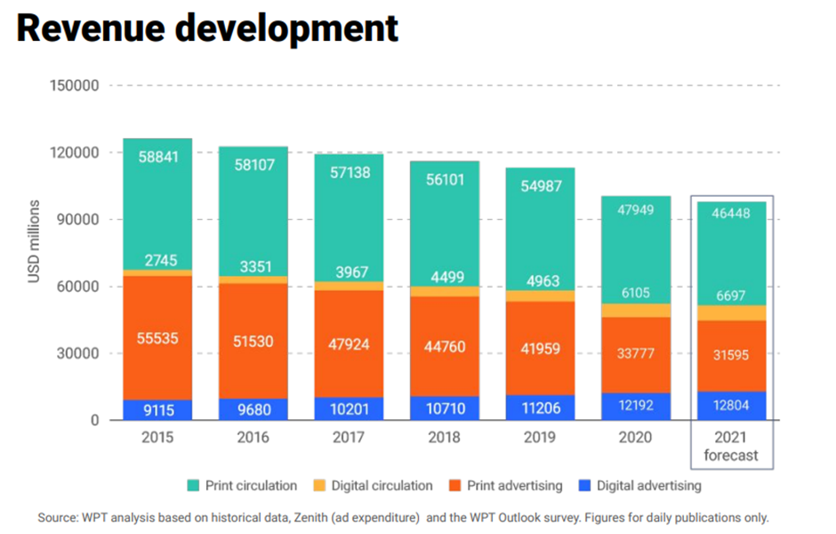

What is sustainability?

The concept of sustainability is connected to the health of the media market. Fair competition, availability of financial resources, and opportunities for growth, can serve as proxies for sustainability. However, in a context of media plurality, the understanding of sustainability is not limited to the existence of media across time. To achieve external pluralism, for which a diversity of media owners and types are needed in any given market, the sustained survival of multiple media companies or providers is necessary, but not sufficient. These aspects of media pluralism depend also on the breadth, variety and quality of the content that is produced and accessed by citizens. Sustainability, therefore, must be intended as the ability to fund a media business model in the long term, and the ability of the media system to continue to provide sufficient scale and variety of quality content, especially of news and informative content, and communication spaces (more explanations on this concept available in Study on media plurality and diversity online, CMPF/EUI et al., forthcoming). Sustainability is also connected with the sustainability of journalism and the journalistic profession, as well as with the public understanding of the social and democratic value of news and the importance of funding for news production.

What is a sustainable business model?

A sustainable business model is the one that relies upon various forms of funding (Study, forthcoming) including:

- Revenues through pay per view/read or through subscription or membership schemes.
- Crowdfunding
- Donations and grants
- State support
4.1) Direct state support
4.2) Indirect state support, including favourable taxation regimes
- Redistribution of copyright revenues (es Publisher’s right, EU copyright Directive)
- Advertising revenue
- Diversification of income streams

A sustainable business model also relies upon the use of consumer data in advertising.

Some examples of good practices:

Subscription and membership schemes: Mediapart in France and the UK’s Guardian have demonstrated success in generating revenue in this way. This is evident thanks to the high level of transparency they have on their ownership structures and revenues which also facilitates accountability towards users. However, their experience also indicates that scale may be necessary.

User payment: Revenue from subscription and direct payment has increased for newspapers in Norway and Sweden in the last 10 years, to 60 percent in Norway (2020), decreasing news media’s reliance on advertising income. The Reuters Digital News Report (2021) attributes this to higher willingness to pay for news among audiences and offering digital/print bundles (Newman et al., 2019). 45% of audiences in Norway pay for news.

State support (also partnerships?): In the UK, the BBC supports local media through a Local Democracy Reporting Service that includes sharing data journalistic capabilities with local media, training programmes and local content. The scheme is funded through the BBC licence. Ideal and voluntary local radio stations in the UK also receive some direct production support. Measures to prevent blind spots also feature in the Swedish support scheme, with direct support to local and regional media. To enable predictability and sustainability in markets in danger of developing blind spots, support is given for three years at a time and covers 75% of editorial costs. Across the Nordic countries, direct state support is directed primarily at covering editorial costs.

Taxation policies: The Canadian Journalism Labour Tax Credit is a 25% refundable tax credit on the total qualifying labour expenditure incurred in respect of each eligible newsroom employee of a qualifying journalism organization less any amount received from the Aid to Publishers at any time in the year.

Diversifying income streams: The Danish publisher JP/Politikens Hus has employed business-to-business services to diversify revenue streams, particularly in the areas of specialised news, e.g., new tailored to target groups such as the agricultural industries and the financial sectors. The Italian “Il Post” is another example of diversification of funding sources (subscriptions, advertising, online classes and more).

Table of contents of Good practices for sustainable media financing

- Executive summary
The summary will outline the key recommendations and best practices from the report.
- Introduction
The introduction will outline the rationale for the report, mapping out the key issues at stake and the major financial challenges for the news media sectors. The introduction will provide an overview of the data included to ascertain sustainability, evaluate the extent to which journalism is underfunded, and outline the development of new business and revenue models in the sector. The rationale will furthermore be anchored in the role of the states in providing a framework for independent journalism as a public good. The aim of the introduction is to provide the framework for identifying good practices for sustainable media funding, with a guideline for how both states and media actors/stakeholders can use the findings of the report.
- A framework of the analysis
The framework will outline the scope of the analysis, the economic perspectives assumed and the regulatory perspectives in which best practices are outlined.
3.1) Scope of the analysis and definitions
The section will outline the scope of the analysis and define “sustainable media financing” in the context of media markets and systems, technological developments, the role of journalism in society and the working conditions of journalists including specifically women journalists. The section also accounts for geographical scope at the national and local levels.
3.1.1. Economic perspective
The section will outline the economic perspective and the scope of revenue sources under consideration, including outlining the income and business model of journalistic media, state support schemes and audience/advertising revenues in the news industries.
3.1.2 Regulatory perspective
The section will present the relevant regulatory instruments under consideration, including the various support schemes of member states, the range of direct and indirect support schemes, and the conditions for support. This section will also summarise the normative goals supporting media regulation and state support mechanisms.
- Methodology used in the data collection and selection of the good practices
This section will give an overview of the methodology used to collect insights and information that will feed into this report. The report will be primarily based on desk research and a literature review of relevant academic research, industry and policy publications. These insights could then be integrated with a data collection that includes a survey filled in by member states’ representatives.
4.1.) Desk research
Desk research will consist of a literature review of relevant research, reports from relevant ministries of MSs, comparative literature as well as regulatory documents from member states.
4.2.) Survey to MSs
The survey will aim to map revenue generation in the news media sectors, the number of journalists employed and the share of the advertising market. The survey will also ask questions about the regulatory framework of member states, how public service media are funded, and the presence of direct subsidies. The survey will furthermore ask respondents to report best practices.
- Analysis of best practices
Based on the results of the research, the report will outline best practices within direct payment/subscription models, advertising models, crowdfunding and donations/grant models, direct and indirect state support schemes, schemes for redistributing copyright revenue, as well as efforts to diversify income streams. These are likely to include membership schemes such as the UK’s Guardian, partnership models where public service media provide support to local news structures (e.g., in the UK), and innovation funding models such as can be found in the Nordic countries.
- Conclusions
The conclusions will outline the main findings of the report and recommended good practices for sustainable media financing
- Summary of Council of Europe relevant documents
- References

Documents quoted in this draft:
- EUI/Centre for Media Pluralism and Media Freedom, et al., Study on media plurality and diversity online, forthcoming 2022 ( The Study funded by the European Commission and was carried out by a consortium led by CMPF (EUI) and including CiTiP (Centre for Information Technology and Intellectual Property) of KU Leuven ; the Institute for Information Law of the University of Amsterdam (IViR/UvA); the Vrije Universiteit Brussels (Studies in Media, Innovation and Technology, VUB- SMIT).
- Bleyer-Simon, Konrad, Brogi, Elda, Carlini, Roberta Maria, Nenadic, Iva, Palmer, Marie, Parcu, Pier Luigi, Verza, Sofia, Viola De Azevedo Cunha, Mario, Žuffová, Mária, Monitoring media pluralism in the digital era : application of the Media Pluralism Monitor in the European Union, Albania, Montenegro, Republic of North Macedonia, Serbia & Turkey in the year 2020, Centre for Media Pluralism and Media Freedom (CMPF), 2021, Country Reports (https://hdl.handle.net/1814/71970), retrieved from Cadmus, EUI Research Repository.
- Newman, N., Fletcher, R., Kalogeropoulos, A., Levy, D. A., & Nielsen, R. K. (2019). Reuters institute digital news report 2019. Reuters Institute for the Study of Journalism.
- Newman, N., Fletcher, R., Schulz, A., Andi, S., Robertson, C. T., & Nielsen, R. K. (2021). Reuters institute digital news report 2021. Tenth Edition. Reuters Institute for the Study of Journalism.

This outline is mostly based on the Study on media plurality and diversity online, CMPF/EUI et al., forthcoming July 2022 (funded by the European Commission).
https://www.ilpost.it/2022/05/06/conti-post-2021/#:~:text=Ci%20eravamo%20lasciati%20un%20anno,un%20attivo%20di%20659mila%20euro.

